
SUBMITTED TO: -

B.K.D.K.M
SANCHALIT

B.C.A. & P.G.D.C.A COLLEGE
PALANPUR-385 001

AFFILIATED TO:-
NORTH GUJARAT UNIVERSITY, PATAN

Project Guide Principal

Mrs. Namrata Gupta Mrs. Namrata S.Gupta
(BKDKM SANCHALIT B.C.A. &
P.G.D.C.A .COLLEGE, PALANPUR)

BANASKANTHA DISTRICT KELVANI MANDAL
SANCHALIT
B.C.A. AND P.G.D.C.A. COLLEGE,
PALANPUR – 385 001.
2009-2010.

TO WHOM SO EVER IT MAY CONCERN:

This is to certify that following students of B.C.A . have completed their project work on "On Matrimonial Site(MiLaap.com)" of HEMCHANDRACHARYA NORTH GUJARAT UNIVERSITY, Patan in the academic year 2011-2012.

NAME OF STUDENTS ROLL NO EXAM NO.

Thakkar Varsha R 182
Thakur Nikita P 183

Project Guide Principal

Mrs. Namrata S. Gupta Mrs. Namrata S. Gupta

(BKDKM SANCHALIT B.C.A. & P.G.D.C.A. COLLEGE,
PALANPUR)
(Affiliated To: North Gujarat University, Patan)



CERTIFICATE

This is to certify that Miss. Varsha Thakkar & Miss. Nikita Thakur have worked on the project given- by B.K.D.K.M Sanchalit BCA College,Palanpur-385001.

They have developed "Matrimonial Site (MiLaap.come)” project in ASP.NET as front end & SQL server 2003 as Back end Tool and Data Report on Matrimonial site (MiLaaP.com).

The time duration of the project is from 24th April 2010 to 21st June 2010(50 Days).

The System is verified by us and found suitable for implementation at our Branch during their project work.

No Student Name Roll No. Exam No

1. Thakkar Varsha R 182

2. Thakur Nikita P 183

Acknowledgement

“Gratitude is feeling which is more eloquent then words, more silent then silence”

“Learning is a continuous process”. The successful accomplishment of a project of this stature brings great delight and a sense of fulfillment. At this moment of realization of our substantial enhancement, as a person as well as a professional, we do not have enough words to express our gratitude towards those who have contributed in one way or the other during our Project Training period.
We are very thankful to have as a internal guide Mrs. Namrata Gupta. It would not have been possible to complete our project with this accuracy and satisfaction without her guidance and the innovative ideas that he provided during our project. She has provided constant guidance, support and encouragement during the project tenure. We thank her for her guidance, invaluable time and efforts. We appreciate her interest and concern regarding our career. we would like to extend our sincere thanks to all other Faculty to help us for solving our Queries.
We are very much thankful to our parents for their constant support & motivation. At last but not least, we thank all our friends, family and those whose names have not appeared here but those contributions have not gone unnoticed.

SR.  NO. | DESCRIPTION | PAGE NO.
1. | PROJECT PROFILE
2. | ABOUT THE INSTITUTE
3. | ABOUT THE UNIVERSITY
4. | NEED FOR NEW SYSTEM
5. | REQUIRMENT OF HARDWARES AND SOFTWARES
6. | ABSTRACT
7. | DATA FLOW DIAGRAM
8. | DATA DICTINORY
9. | INPUT DESIGN
10. | OUTPUT DESIGN
11. | BIBLIOGRAPHY

Project Profile

Project Title | Matrimonial Site (MiLaaP.com)
Project Category | Web-Based Application using.NET Technology.
Team Member | 2
Software Specification | Front End | Visual Studio.NET 2008  Using : C#.net
Software Specification | Back End | SQL Server 2008
Operating System | Windows XP
Hardware Specification | PC with 40 GB hard disk and 1GB RAM.
Submitted By | Thakkar Varsha R.  Thakur Nikita P.
Submitted To | H.N.G.University, Patan.
Internal Guide | Mrs. Namrata Gupta.
External Guide

ABOUT THE INSTITUTE


BKDKM Sanchalit BCA and PGDCA College Was Established By Well-Known Philanthropic Trust “Banaskantha District Kelvani Mandal”. To Provide Higher Education For Training To Young Generation In Science, Commerce, Arts, Law and Computer Studies.

The institute is situated at the Entrance of Palanpur in the good environs. The institute has adequate facilities to provide better education including familiar faculties. The entire atmosphere provides a refreshing environment that stimulates intellectual alertness, creativity and desire for learning.

It is affiliated to the “Hemchandracharya North Gujarat University”. And it offers three year fulltime BCA and One year fulltime PGDCA courses.


Address: Opp.S.T.Workshop
Highway, Palanpur,
385001
Gujarat. India.
Phone: [02742]-266348

About The University

The area of the state known as North Gujarat is constituted of four districts Patan, Mehsana, Banaskantha, and Sabarkantha. The University was established with a view to cater the cultural and educational needs of these districts on 17th may, 1986 by the Governor's Ordinance No.5 of Gujarat and the University was suitably established, Earlier the districts were covered under the Gujarat University, on division from its parent university, no corporal assets were inborn and it started running as initial. The university has been functioning since then and growing and expanding steadily.

Patan, a historical town has been officially designated as the Head Quarter of the University. For centuries it had been the capital city of large kingdom of present-day Gujarat under the Solanki rulers and a very important seat of join in scholarship. It is the holy and of Hemchandracharya, a great thinker who made valuable contribution to the studies of grammar, literature, religion and idea.

5. NEED FOR NEW SYSTEM

CURRENT MANUAL SYSTEM

As we find many disadvantages in manual system, there are two options with us. In the current manual system we have to work manually. In manual system we have to make every type of register manually with validation, but in this system we gain report as per our requirements in a moment.

- DISADVANTAGES OF MANUAL SYSTEM

- Require more accuracy
- Require more resources
- High probability of error
- Highly cumbersome
- Maintenance problem

How this new one can be useful?

- To improve it.
- To find out other more effective system.

Matrimonial site falls in the second category. Everything that describes as disadvantages of the current manual system becomes advantages here. Literally you can do everything that is needed, electronically by just pressing the specified buttons and filling required information.

- We have tried to make it very user friendly and understandable
- Need not to say Computers are very fast and accurate so obviously errors will be less.
- It will very speedily so we can save our time.
- One does not find cumbersome since he just needs to enter data as instructed.
- The major problem of database sorting, manipulating and maintenance is handled very nicely.

REQUIREMENTS

Hard wares Requirements

    - 256 MB RAM
    - Pentium 4, 2GHz processor
    - Color Monitor LG CRT
    - Hard Disk Drive of 40 GB
      - Serial Mouse = Optical mouse
      - Keyboard
- Printer

Software Requirements

Following packages are required for installation of Online Share Trading.

- Operating System :- Windows XP

- IDE :- Visual studio .net 2008 using c#

- DBMS :- SQL server 2008

- Report Generator :- Data Report

ABSTRACT

This Project “Matrimonial Site” deals with the task of defining and executing rules. It includes RuleSetEditor where rules are maintained and Rule Execution where existing rule are execute.This project is generated through .Net Technology. We use Microsoft’s Visual Studio 2008 to generate this project. We use,

Front - end: ASP.NET 3.5
Back – end: MS SQL Server 2005

This Project deals with to help the users to change business application rules dynamically. This would totally remove the necessity of compiling the application every time when any rule/work flow gets change.

Business Rules Engine empowers business experts to change business rules dynamically without any intervention with application developers, thus reducing Turnaround Time in applying business rules. Basic concept of business rules engine is to separate the business logic from the system logic allowing substantial changes in system behavior without substantial changes in code.

DATA FLOW DIAGRAM

Context Level

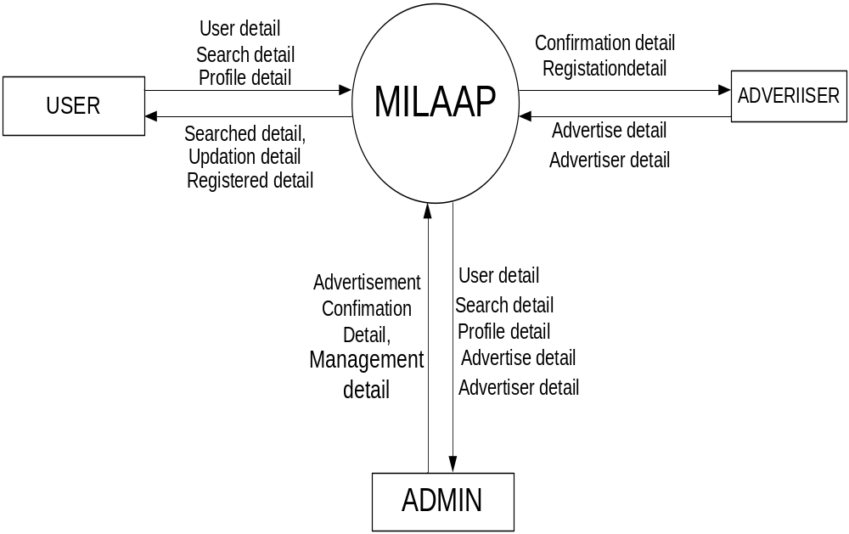

First Level:-
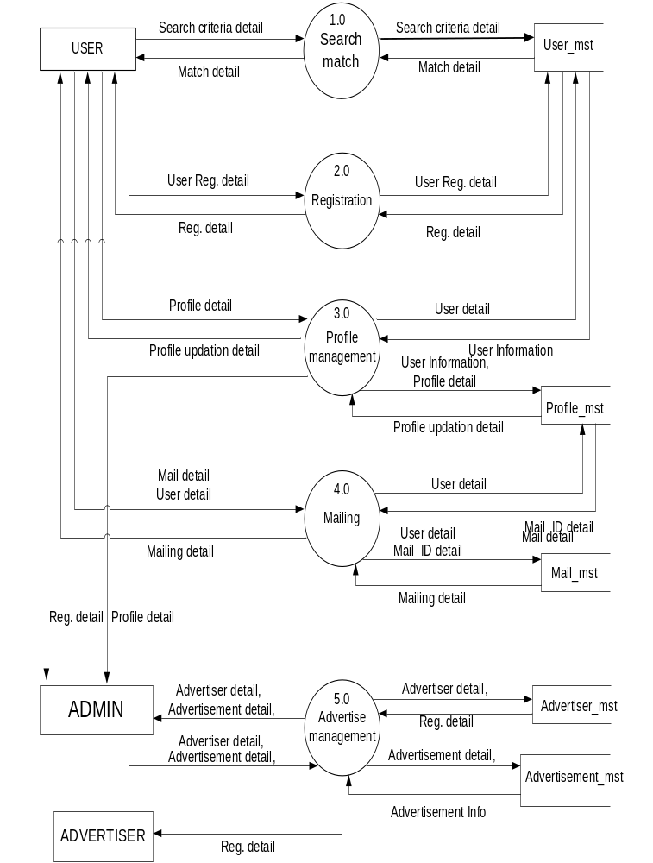
Second Level for process 2.0:-

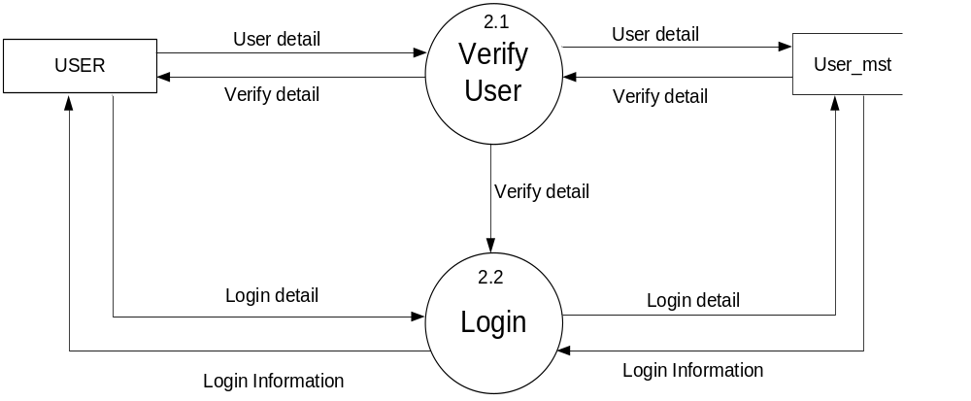

Second Level for process 3.0:-

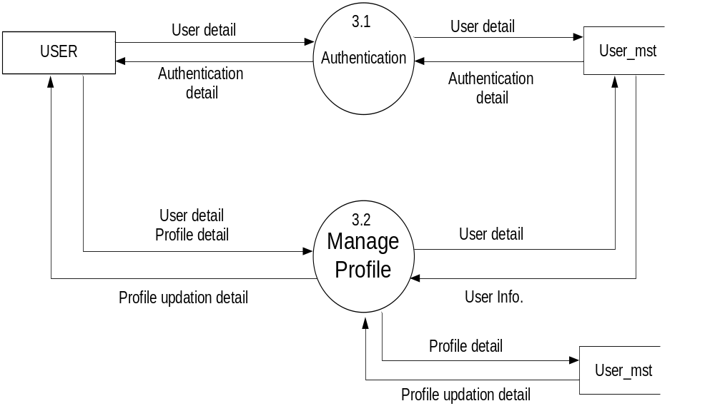

Second Level for process 4.0:-

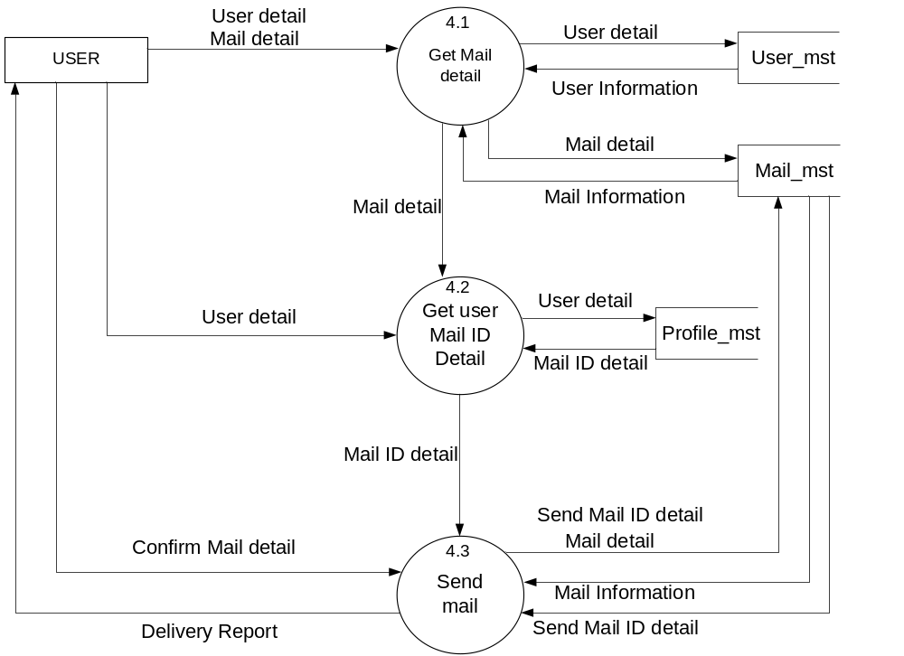

Second level for process 5.0:-
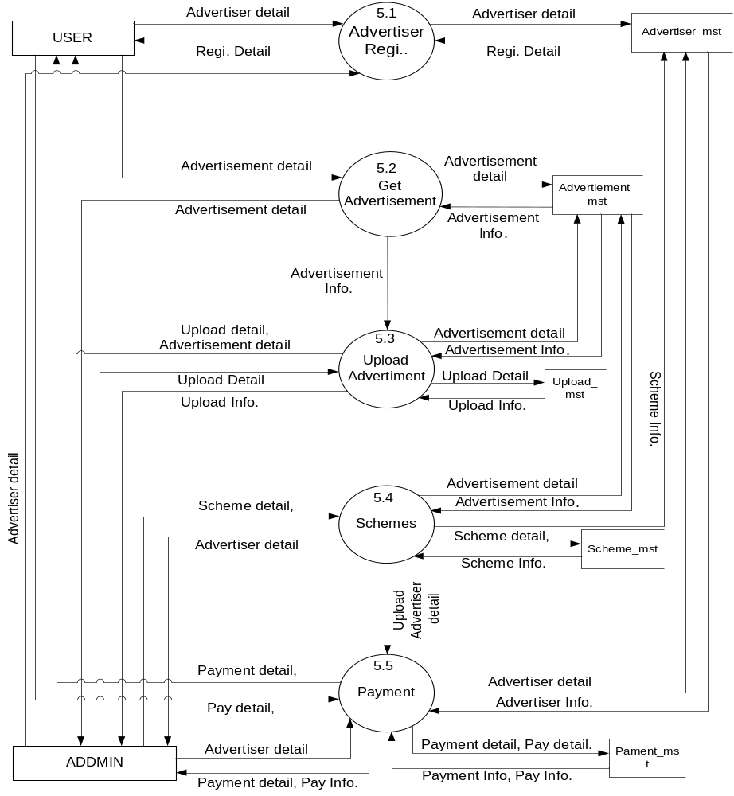
Third level process 5.4:-

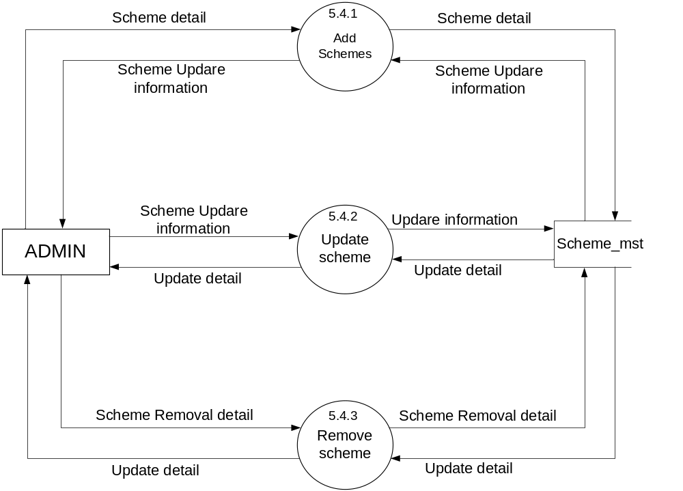

User_Mst:

Field Name | Data Type | Size | Constraint | Description
User_ID | Integer | 4 | Primary Key | This field stored uniq id of user
User_Name | Varchar | 28 | Not Null | This field stored id of user for milaap site
Password | Varchar | 16 | Not Null | This field stored Passwod for user
Name | Varchar | 50 | Not Null | This field stored full name of user
Gender | Bit | 1 | Not Null | This field stored gender of user
DOB | Date Time | 8 | Not Null | This field stored date of birth of user.
Rashi | Varchar | 10 | Allow Null | This field stored Rashi of user
Religion | Varchar | 30 | Not Null | This field stored Religon of user
Caste | Varchar | 30 | Allow Null | This field stored caste of user
Profession | Varchar | 30 | Allow Null | This field stored profession of user
Living | Varchar | 30 | Allow Null | This field stored city of user
Code | Varchar | 20 | Not Null | This field stored code for register that generate randomly.

Profile_Mst:

Field Name | DataType | Size | Constraint | Description
P_ID | Integer | 4 | Primary Key | This field stored unique id of user profile
User_ID | Integer | 4 | Foreign Key | This field stored unique id from parent table
Contact no | Varchar | 15 | Allow Null | This field stored contact number of user
Marital Status | Varchar | 10 | Allow Null | This field stored marital status of user
Mangalik | Varchar | 10 | Allow Null | This field stored manglik information of user
Annual Income | Float | 5 | Allow Null | This field stored annual income of user
Hobbies | Varchar | 50 | Allow Null | This field stored hobbies of user
Address | Varchar | 100 | Allow Null | This field stored full address of user
PrimaryEducation | Varchar | 20 | Allow Null | This field stored primary education of user
UnderGraduate | Varchar | 20 | Allow Null | This field stored under graduation info. of user
Degree | Varchar | 20 | Allow Null | This field stored degree name of user
PostGraduate | Varchar | 20 | Allow Null | This field stored master degree of user.
Height | Integer | 5 | Allow Null | This field stored height of user
Weight | Integer | 5 | Allow Null | This field stored weight of user.
Health | Varchar | 10 | Allow Null | This field stored health of user
SkinColour | Varchar | 10 | Allow Null | This field stored skin colour of user.
EyeSight | Bit | 1 | Allow Null | This field stored user’s eye sight of user.
FatherName | Varchar | 30 | Allow Null | This field stored father name of user.
FatherOccuption | Varchar | 30 | Allow Null | This field stored father occupation of user.
MotherName | Varchar | 30 | Allow Null | This field stored mother name of user.
MotherOccuption | Varchar | 30 | Allow Null | This field stored mother occupation of user.
Maternal | Varchar | 30 | Allow Null | This field stored name of maternal relation.
Paternal | Varchar | 30 | Allow Null | This field stored name of paternal relation.
Email-ID | Varchar | 30 | Not Null | This field stored Email-ID of user.
Photo | Varchar | 50 | Allow Null | This field stored photo of user.

Mail_Mst:-

Field Name | Data Type | Size | Constraint | Description
M_ID | Integer | 4 | Primary key | This field stored unique id of user.
User_ID | Integer | 4 | Foreign key | This field stored unique id from parent table.
Email_ID | Varchar | 100 | Not Null | This field stored Email id of user.
Mail Detail | Varchar | 30 | Allow Null | This field stored mail detail of user.
Attachment Detail | Varchar | 40 | Allow Null | This field stored attachment detail of mail.
Status | Bit | 1 | Not Null | This field stored

Advertiser_Mst:-

Field Name | DataType | Size | Constraint | Description
A_ID | Integer | 4 | Primary key | This field stored unique id for advertiser.
Name | Varchar | 40 | Not Null | This field stored name of advertiser.
Address | Varchar | 100 | Allow Null | This field stored address of advertiser.
ContactNo. | Varchar | 15 | Allow Null | This field stored contact number of advertiser.
Advertiser type | Varchar | 15 | Not Null | This field stored type of advertiser.
Email_ID | Varchar | 30 | Not Null | This field stored Email_ID of advertiser.

Advertisement_Mst:-

Field Name | DataType | Size | Constraint | Description
Ad_ID | Integer | 4 | Primary key | This field stored unique id of advertisement
A_ID | Integer | 4 | Foreign key | This field stored unique id of advertiser from parent table
AdvertisementName | Varchar | 50 | Not Null | This field stored name of the advertisement.
Days | Integer | 5 | Not Null | This field stored days of showing advertisement.
AdvertisementType | Varchar | 15 | Not Null | This field stored type of advertisement.
AdvertisementDetail | Varchar | 100 | Not Null | This field stored detail of advertisement.
AdvertisementStartDate | Varchar | 8 | Not Null | This field stored starting date of advertisement.
AdvertisementEndDate | Varchar | 8 | Not Null | This field stored ending date of advertisement.

Upload_Mst:-

Field Name | DataType | Size | Constraint | Description
Up_ID | Integer | 4 | Primary key | This field stored unique id of uploaded ads.
A_ID | Integer | 4 | Foreign key | This field stored unique id of advertiser from parent table.
Ad_ID | Integer | 4 | Foreign key | This field stored unique id of advertisement from parent table.
Start Date | Date Time | 8 | Not Null | This field stored start date for uploading ads.
End Date | Date Time | 8 | Not Null | This field stored end date for uploading ads.
Duration | Date Time | 8 | Allow Null | This field stored duration for uploading ads.

Payment_Mst:-

Field Name | DataType | Size | Constraint | Description
Pay_ID | Integer | 4 | Primary key | This field stored unique id of payment bills.
A_ID | Integer | 4 | Foreign key | This field stored unique id advertiser from parent table.
Ad_ID | Integer | 4 | Foreign key | This field stored unique id of advertisement from parent table.
Total payment | Float | 10 | Not Null | This field stored total payment of uploaded ads.
Paid | Float | 10 | Not Null | This field stored RS. That advertiser paid.
DateTime | Date Time | 8 | Allow Null | This field stored date and time of paid RS.

Scheme_Mst:-

Field Name | DataType | Size | Constraint | Description
Sch_ID | Integer | 4 | Primary key | This field stored unique id for schemes of ads.
SchName | Varchar | 30 | Allow Null | This field stored name of the scheme.
SchStartDate | DateTime | 8 | Not Null | This field stored start date of schemes
SchEndDate | Date Time | 8 | Not Null | This field stored end date of schemes.
SchDetail | Varchar | 50 | Allow Null | This field stored details of schemes.

